EXPERIMENT – 3 Multi-Byte Data and Array Operations Using 8086 Indirect Addressing
Objectives of this Experiment:
1. To add two numbers using register-indirect and based addressing.
2. To find the sum of N 16-bit numbers stored in a word array.
3. To add two 64-bit numbers byte by byte with carry propagation using a loop.
2. To find the sum of N 16-bit numbers stored in a word array.
1. Program

8086 program
MOV SI, 2000H
MOV CX, 0005H
MOV AX, 0000H
NEXT: ADD AX, [SI]
ADD SI, 02H
LOOP NEXT
MOV [2010H], AX
HLT

2. Data Input (Memory)
Memory
Address Data
2000H 1234H
2002H 2345H
2004H 1111H
2006H 2222H
2008H 3333H

3. Output
Register / Memory Address Output
AX 9BDFH
2010H 9BDFH
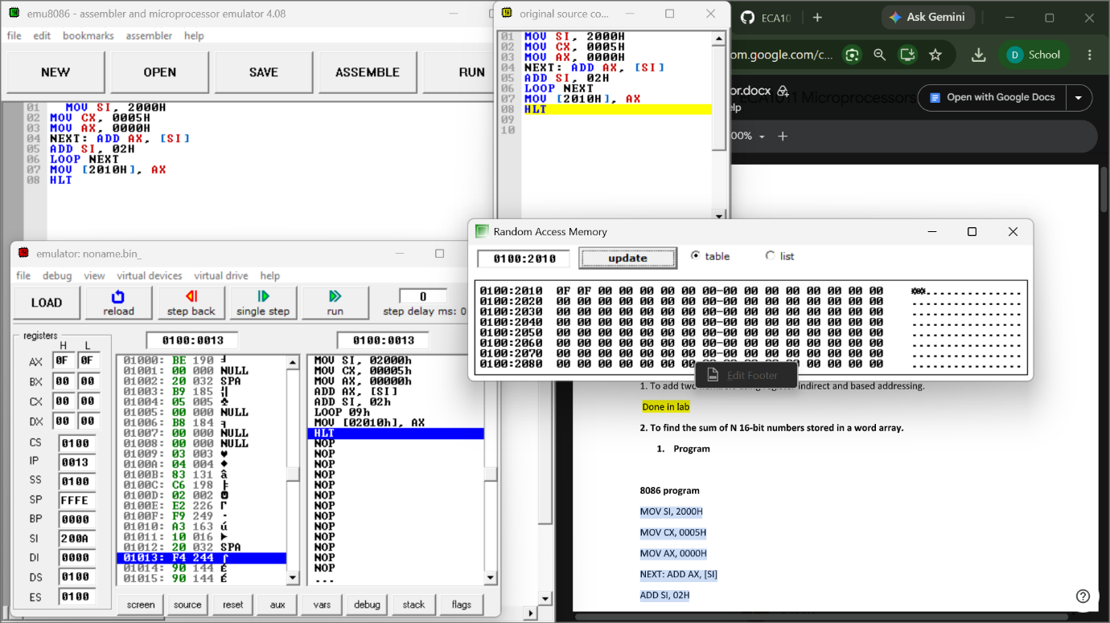

3. To add two 64-bit numbers byte by byte with carry
propagation

8086 Program – Addition of Two 64-Bit Numbers
Starting Address: 1100H
Program
MOV SI, 2000H
MOV DI, 2008H
MOV BX, 2010H
MOV CX, 0008H
CLC

NEXT: MOV AL, [SI]
ADC AL, [DI]
MOV [BX], AL
INC SI
INC DI
INC BX
LOOP NEXT

MOV AL, 00H
ADC AL, 00H
MOV [2018H], AL

HLT
Input Data

First 64-bit Number
Addres
s
Dat
a
2000H 12H
2001H 34H
2002H 56H
2003H 78H
2004H 9AH
2005H BCH
2006H DEH
2007H F0H
Second 64-bit Number
Addres
s
Dat
a
2008H 11H
2009H 22H
200AH 33H
200BH 44H
200CH 55H
200DH 66H
200EH 77H
200FH 88H
Output Data
Addres
s
Resul
t
2010H 23H
2011H 66H
2012H 89H
2013H BCH

2014H EFH
2015H 64H
2016H 95H
2017H 79H
2018H 01H
Final Result:
179564EFBC896623H
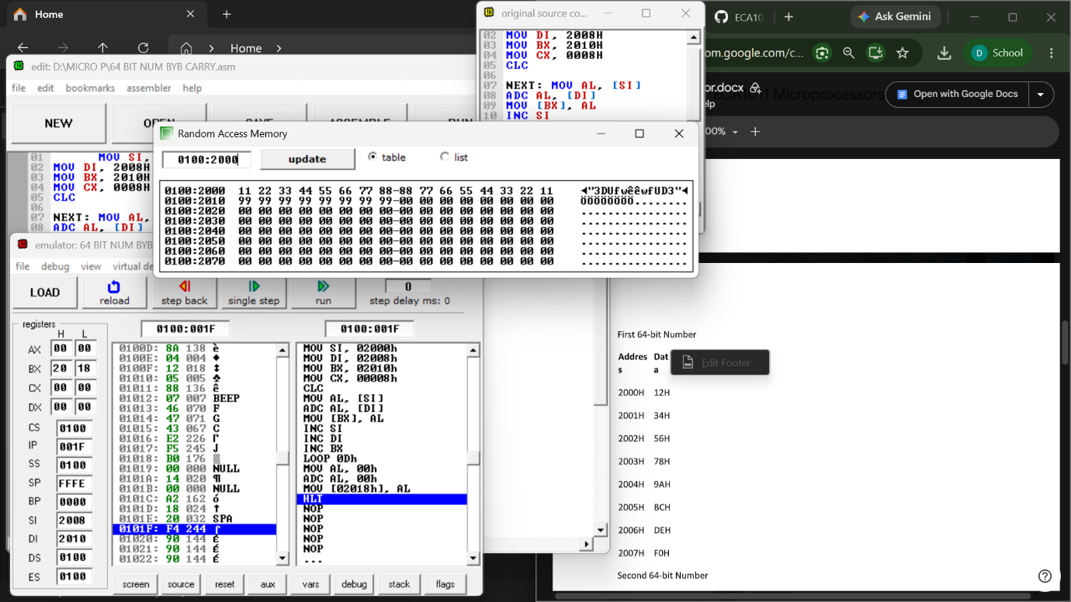

RESULT:
Thus, the 8086 microprocessor multi-byte data and array operations were successfully executed. The sum of five 16-bit numbers was calculated using indirect addressing, and the addition of two 64-bit numbers was performed byte by byte with proper carry propagation. The expected results were obtained and stored in the specified memory locations.

